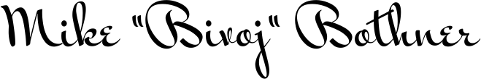
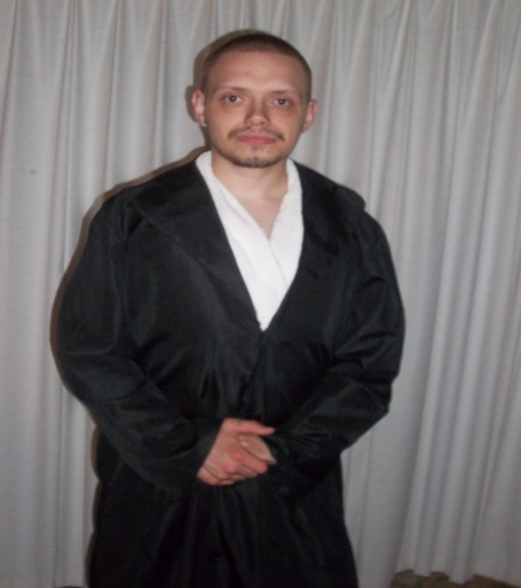
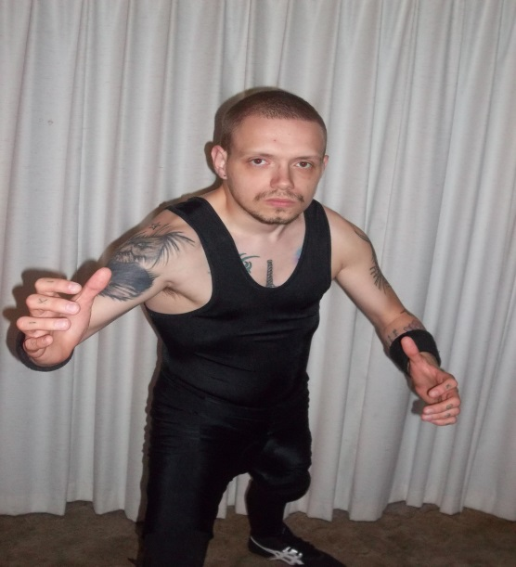
- Name: Michael Proffitt (Professionally known as Mike “Bivoj” Bothner)
- Height: 5’5” (167.6 cm)
- Weight: 130 lbs. (9.35 Stone, 59.38 kg.)
- Global Wrestling Historian
- Amateur Wrestler in High School
- Trained professionally by: WWE Hall of Famer, Handsome Jimmy “The Boogie-Woogie Man” Valiant at “Boogie’s Wrestling Camp” in Shawsville, Virginia, U.S.A. in 2007. +Graduate of the “B.W.C.” Class of 2008.
- Practiced Catch Wrestling and Submission Grappling by his own will.
- Trained and experienced Official (Referee)
- Retired at the end of 2011

- Finishing Maneuvers:
• Snap Mare Driver
• Anaconda Vice (Arm Trap Triangle Choke)

- Other Signature moves:
• Short Arm Scissors
• Brain Buster (Falling Raised Half-Suplex)
• Various Chops
• “Shotei” (Japanese Strong Style Palm Strike to the shoulder or chest)

- Exercised by using own body weight as resistance, various Push-Ups (Including One Hand, Diamond, Normal Shoulder Width, Clap Push Ups), Crunches and Sit Ups, Lunges and hard-stretching, Cardio, and lifting weights such as iron bars and plates, and barbells in a series of many reps of medium weight, instead of few repetitions with a very heavy amount.

